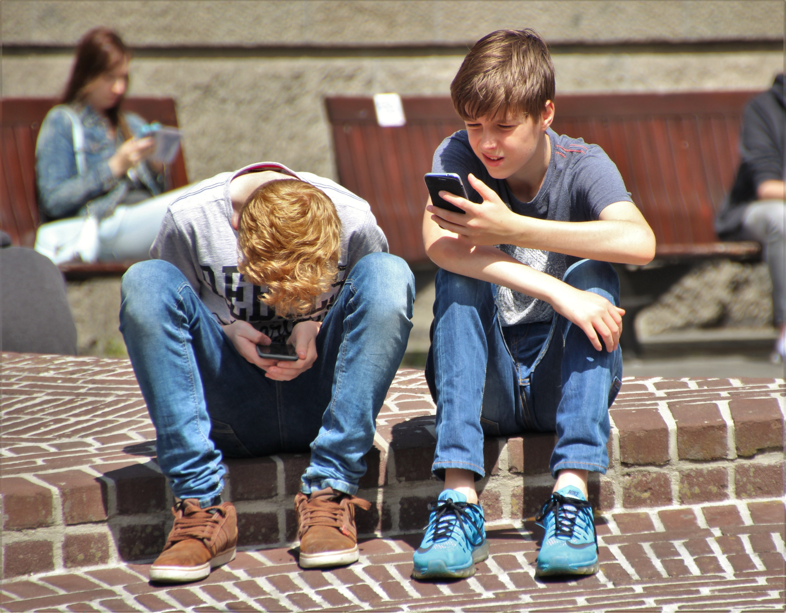  Middle school Boys  who are at risk of getting lost behind the screen  The complexities of middle school are difficult for even the best kids. Hiding behind a screen is a tactic to avoid the tough choices of navigating this difficult terrain. I am hosting a small group to help our young men to stay strong in who they are so they can make choices to support solid relationships.  The group will meet Saturdays for 4-week blocks. Each participant can continue with the next 4-week block if desired.  When the world makes you think you don’t fit in.  Well, you do. | SATURDAY GROUP  ────  Only $25 for  60-minute group session  ────  Over 25 years of work with middle school youth  ────  Different  is not bad  ────  Parents, please call for more details  ────  Fry LCSW inc.  360 Prospect Place  Alpharetta Ga 30005  866-525-2128  www.FryLCSW.com

